Legal and ethical update workshop
Friday February 11, 2022

Earn 6 CEU’s while you learn…
- Legal and ethical considerations for communicating with attorneys.
- Appropriate ethical documentation practices
- Learn about legal access to records and risks of denying access.
- Explore the special legal and ethical considerations when treating minors.
- Explore the process of a Board investigation and disciplinary action and the things that may generate them.
- Practices for maintaining appropriate boundaries with clients and collaterals.
- How informed consent and confidentiality requirements differ between individual therapy and family therapy.
- Explore the legal and ethical requirements for determining when and how to report suspected abuse.
- Explore the legal and ethical requirements for compliance relating to the practice of behavioral health care during Covid.
- Determine the legality of practicing across state lines
- How to ethically practice telehealth

When: 8:30am-4:30pm, with event registration beginning at 8:00am

Location: Phoenix Plaza Civic Center, 220 N. Main St.,Phoenix, OR 97535

Cost: MHREN Members $90 – Non-Members $110, $20 additional for late registration starting Saturday, February 5th.

Payment: Mail or PayPal
- Checks Payable to MHREN, mailed to P.O. Box 1349 Talent, OR 97540
- Visit: www.MHREN.org to pay online
Paul A. Cooney, J.D., is a healthcare attorney who has been in practice for 23+ years. Mr. Cooney is managing partner at Cooney, Cooney and Madigan, LLC where he specializes in healthcare litigation and represents a wide variety of healthcare professionals in all aspects of their practice. Mr. Cooney is general counsel for the Oregon Psychological Association. He represents mental health professionals in malpractice cases, licensing and discipline matters, as well as general business matters. He is licensed to practice in both Oregon and Washington and is a frequent speaker on legal issues and risk management.

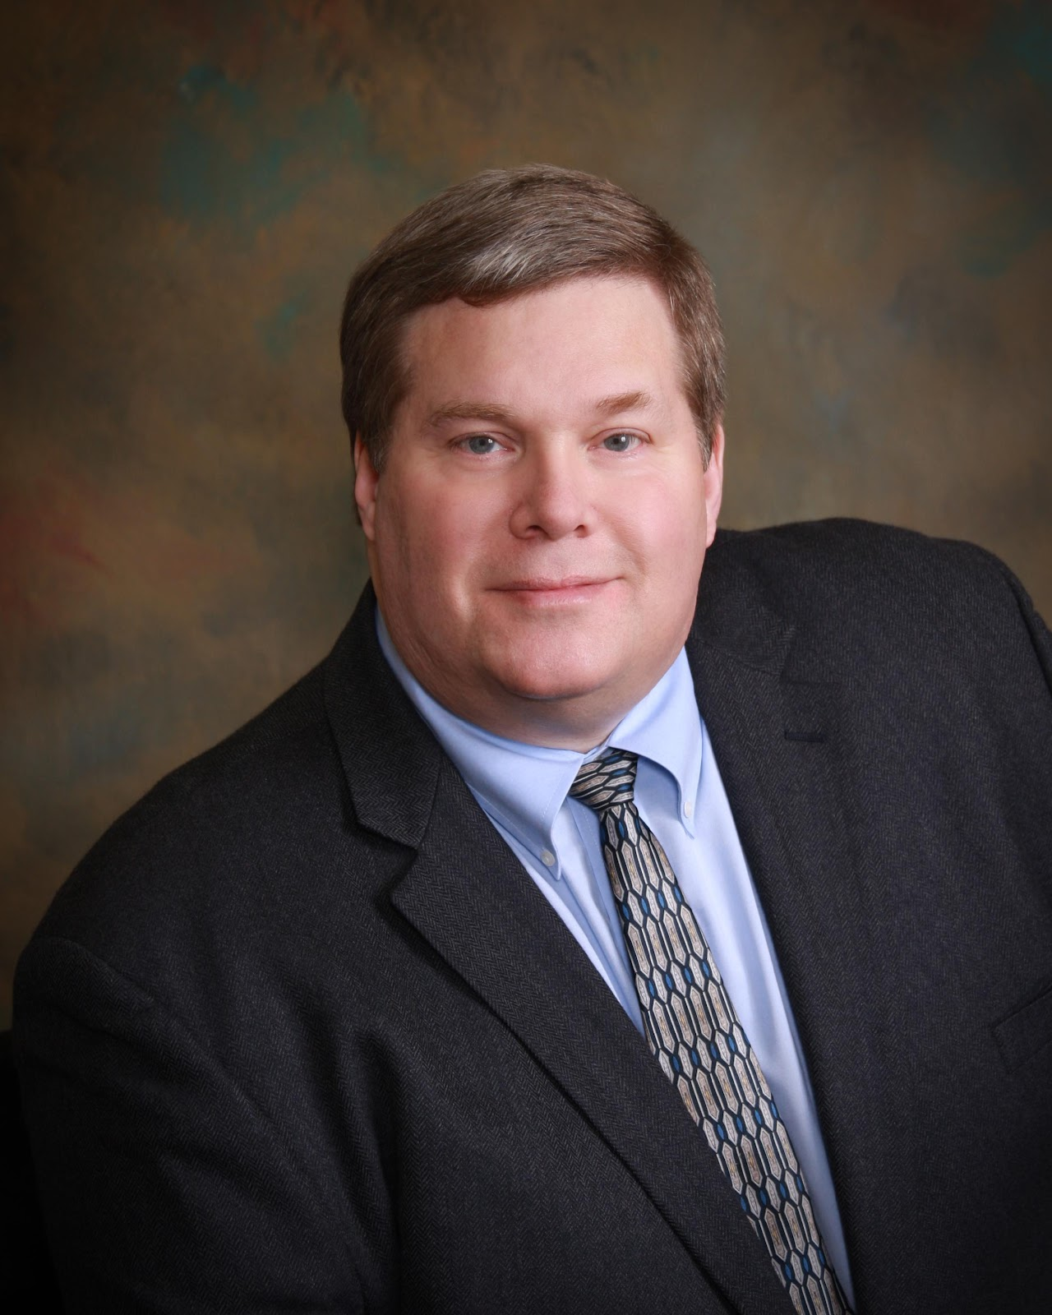

Covid-19 Policy: Proof of Vaccination Required, See Details Attached: If you have tested positive for COVID-19 or have been around someone that tested positive for COVID-19 in the 14 days prior to the event, please do not attend this event in-person. You may attend the conference remotely, via livestream, with details to follow.
The workshop will be livestreamed to participants who choose not to participate with the in-person format. A link will be provided upon registration confirmation.

Testimonials: "I have attended training provided by Paul and found him to be very approachable, knowledgeable, and extremely helpful. His thorough knowledge of the Oregon statutes was clearly presented. His long experience representing Oregon behavioral health professionals and his genuine appreciation of the work we do make his presentation both meaningful and relevant." - Martha Hutchison LCSW
"Paul has given workshops before for Rogue Valley mental health professionals. Each time he presents, he provides professionals with crucial and valuable information on the ethics and rules guiding our work with clients. Unlike many other ethics presentations available, Paul's workshops are specific to Oregon's rules and regulations. He is an invaluable resource." - Sharon Bolles, LPC
Mental Health resource and Education network
P.O. Box 1349 Talent, OR 97540
Email: MHRENboard@gmail.com
www.MHREN.org

